|  |  |  |  |
| --- | --- | --- | --- |
| **C** | **C** | **C** | **C** |
| Sharing thoughts, questions, ideas & solutions | Working together to reach a goal. Putting talent, expertise and smarts to work | Looking at problems in a new way and linking learning across subjects & disciplines | Trying new approaches to get things done equals innovation & invention |

21st Century Skills

The Four Cs? (Label the definitions)

Practical tasks

Activity 1: Animals (Levels: A2 – B1)

Steps:

1. Hand out pictures (one picture per student)
2. Students find two other students with a different picture
3. Students label the animals without dictionaries (ask each other)
4. Students categorise the animals into groups, eg. legs vs other, fur vs other, herbivores vs carnivores, farm vs zoo, land vs water (sea, river)
5. Teacher asks students to agree to which animals are pets.
6. Students decide which make the best pets and why?
7. Students deliver presentations
8. Homework: write a summary of their presentation.

Animals 1

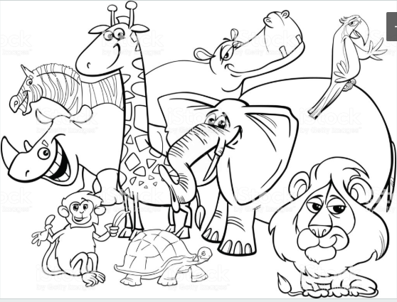

Animals 2

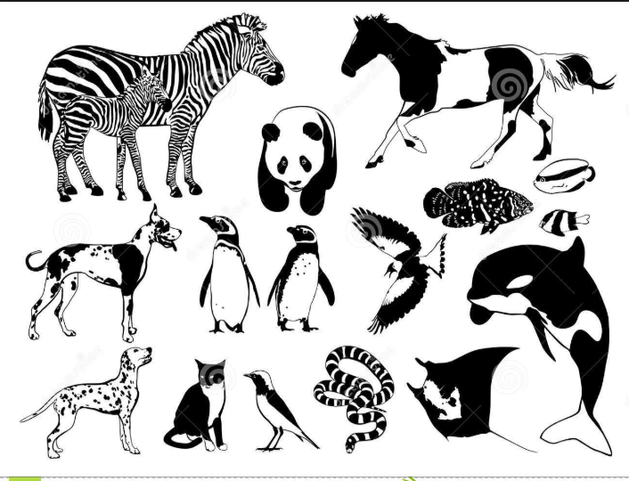

Animals 3

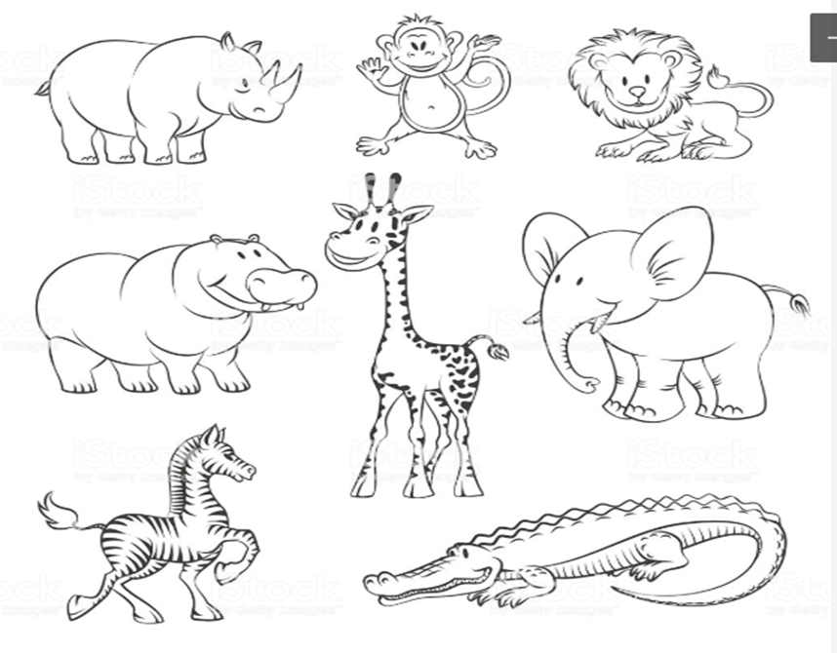

Activity 2: COVID-19 Information Campaign (Levels B2 – C2)

**Reading: Bondi virus outbreak: Backpackers spread COVID-19**

31st Mar 2020, Source: <https://www.thechronicle.com.au/news/bondi-virus-outbreak-backpackers-spread-covid-19/3985426/>

NSW authorities have confirmed there's been a coronavirus outbreak among backpackers in Bondi, in Sydney's east, after hundreds were captured ignoring social distancing measures. Dr Kerry Chant confirmed there had been an outbreak of COVID-19 among backpackers in Bondi, in Sydney's east. "We know there is a potential risk that other members of the community may have come in contact with infected backpackers," she said. "We have had a small number of cases in that community where there aren't obvious links, but a plausible explanation is they have come into contact with an infected backpacker before that backpacker was aware they had COVID-19."

It comes as Australia records 4363 cases of coronavirus with 19 deaths. As of Tuesday morning, there were 2032 in NSW, 821 in Victoria, 689 in Queensland, 305 in South Australia, 355 in Western Australia, 69 in Tasmania, 78 in the Australian Capital Territory and 15 in the Northern Territory. Globally, there have been nearly 740,000 cases of the disease recorded with more than 35,000 deaths. The US and Europe are now the epicentre of the outbreak, which began in mainland China in late December 2019.

Questions

1. What happened to the backpackers in Bondi?
2. Why did this happen?
3. How does this affect other members of the community?

Group discussion

In your group, write a list of reasons why you think backpackers are ignoring social distancing measures.

Group research

Using the internet as your main source of information, find three examples of COVID-19 health and safety information.

Group task

Create an information campaign targeting backpackers with health and safety information in order to reduce the spread of COVID-19.

Your information campaign should include a one-page poster (flyer/pamphlet).

Group presentation

Present your information campaign to the class using the poster.

Your presentation should be targeted at backpackers and you should be able to give the audience a rationale for why your campaign is effective. The audience will take notes and share their thoughts on why it is an effective campaign and how it could be improved.