AGENDA ITEM #20c: BOARD VACANT POSITIONS UPDATE
2021 Notice of AGM and voting instructions will be issued to members on Monday 18 October 2021. There are 2 nominees nominated for re-election and four new nominees. See the NEAS 2021 AGM page for more information - https://neas.org.au/about/agm-2021/
Katherine Olston  (nominated for re-election)  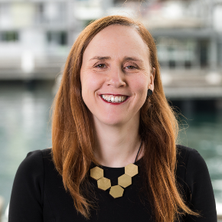 | As a member-elected Director to the NEAS Board since 2018, Katherine is incredibly proud of the work NEAS has done over the past three years to support members and to enhance the quality reputation of our industry. As a NEAS board director, Katherine has always held our members and students at the centre of what we do, and is proud of the way that, through these challenging times, NEAS has been able to be responsive to member needs while also maintaining a focus on the future, working towards the recovery and strengthening of our industry.  Currently, Katherine is the Director at the Centre for English Teaching (CET) and Head of the Learning Hub at the University of Sydney. She oversees pre-entry English language and academic skills pathways courses and post-entry academic support programs in mathematics and academic skills and language development. Under her directorship, the Centre has proactively responded to the emerging demands placed on the industry, developing flexible, robust initiatives and programmes that are responding to seismic changes in circumstances, at both the national and global level. The Centre continues to lead the industry in innovation by embracing the empowering possibilities of technology to provide quality outcomes to students.  Over the past 5 years, in recognition of CET’s contribution to the industry, the Centre has received a number of awards including, Finalist Language Educator of the Year (PIEoneer Awards, 2020), Innovation and Leadership Award (University English Centres Australia, 2019), Best Practice Award for Excellence in Innovation (ATEM, 2018), Award for Innovation (English Australia, 2017, 2018, 2020), Vice Chancellor’s Award for Outstanding Educational Engagement and Innovation (University of Sydney, 2017). CET has also been recognised as a NEAS quality endorsed centre for over 25 years and has three NEAS-endorsed premium products.  Katherine is passionate about advancing the agenda of international education and has over 25 years’ experience in the sector working in a range of English language institutions in Australia and Asia. She is an active contributor and advocate for the industry, contributing through numerous initiatives, including, as a NEAS member elected Director on the NEAS Board since 2018, as member of UECA (University English Centres Australia), Co-convener of the English Australia Post-entry and Academic English Special Interest Group. She regularly represents CET at industry events through conference presentations, workshops, panels and professional development activities (NEAS, English Australia, IEAA, UECA, AIEC).
David Yoo  (nominated for re-election)  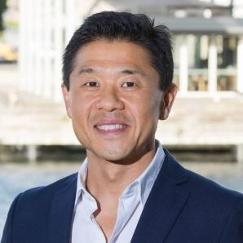 | - Master of Education (International Education)  - Bachelor of Agricultural Economics (Hons)  - Graduate Certificate in Accounting  - Certificate IV in Training and Assessment  I feel privileged to be serving as a member elected Director on the NEAS Board since 2018 and as the Chair of the NEAS Finance, Audit and Investment Committee since 2019, and more recently in 2021, as the Deputy Chair of NEAS. It has been especially rewarding to help NEAS navigate through the most challenging period in the history of Australian international education and for NEAS to now be in a stronger fiscal position than when entering the current COVID-19 pandemic.  I have been a passionate international educator for nearly 30 years, and remain a strong advocate for building a sustainable, diverse and vibrant Australian international education services community.  As a founder, current Board Chair and Managing Director of APC Education Group (AEG), comprising Australian Pacific College, English Unlimited and Virtu Design Institute, we have now assisted over 80,000 international students since 1994 to reach their goals. AEG is very proud to have been the first Australian international education group to announce in March 2020, a COVID-19 Tuition Fee Relief and care packages available to all of our vulnerable students across Australia and for all of our programs, while at the same time meeting all our fiscal and regulatory responsibilities; proving that financial prudence, quality assurance and compassion need not be competing interests, but necessary for a sustainable future for all.  Having served on various industry advisory and State committees including Austrade, Department of Education and Training (DET), Australian Council for Private Education and Training (now ITECA) and English Australia NSW Branch, I will continue to bring diverse educational experience to the NEAS Board, while at the same time draw upon my commercial and financial expertise as a former accountant with Ernst & Young specialising in audit and business services looking after clients, both small and large businesses, across different sectors such as Kambala School, Coca-Cola, Woolworths, Commonwealth Bank, Jones Lang Wootton, Ramsay Health Care and Wesley Mission.  As the Managing Director of a group of private international and domestic providers for over 27 years, I feel there is still much for me to contribute to NEAS and the ELT community as we lead our sector into a brighter post COVID future, and seek your ongoing support as I stand for re-election.

David Ferguson  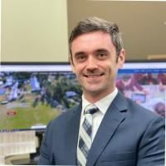 | A highly respected and experienced education leader, David has a great passion for second language development theory and practice. With a background in TESOL, English, Business and Social Sciences, he is committed to broadening horizons, global empathy and perspectives through languages.  As Deputy Head of International Operations at John Paul College, David leads the ELICOS programs, business operations and strategic direction of John Paul International College (JPIC). As part of this role, he advocates for the ‘ELICOS in Schools’ sector, of which NEAS is a key part of quality assurance and compliance in Queensland.  David’s leadership delivers data led solutions that are customer centric, removing barriers and creating positive stakeholder outcomes. In his current role, he has delivered projects to reimagine all aspects of the student, parent and agent journey through innovative and interactive stakeholder engagement mechanisms. David is an enthusiastic contributor to IET discourse communities at conferences and networking events.  David has extensive experience in international education both in Australia and abroad and is a NEAS endorsed Quality ELT Professional. He has post-graduate qualifications in TESOL, Education and Business, and is a member of the Australian Institute of Company Directors. From growing up on the island of Guernsey to living in various places around the world, David brings a critical perspective to executive teams and committees.  After the events of 2020/21 and the likely volatility in 2022, David believes we must take the opportunities presented during these ambiguous, uncertain and competitive times to create new value propositions, target new markets, hone operations in existing markets and reflect.  We must do this by being mindful, selfless and compassionate.

Dr Pamela Humphreys  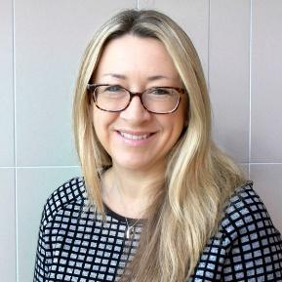 | Dr Pamela Humphreys has worked in international education for over 30 years in Europe, Asia and Australia for a range of both private and public organisations. Currently the Director at Macquarie University International College (MUIC) & English Language Centre (ELC), she has oversight of English language programs, Foundation, Diploma, Undergraduate Certificates, and a suite of online test preparation products which have seen over 800,000 users to date, and two of which were ranked #1 and #3 by FutureLearn in 2020.  In 2021, Pamela was the recipient of the English Australia John Gallagher Bursary for her significant contribution to the ELICOS sector, including:  - NEAS Advisory Council member  - Convenor of the English Australia Post-entry and Academic English Special Interest Group  - Treasurer of UECA  - active contributions to sector submissions to DESE and TEQSA  - involvement in sector benchmarking activities  - sharing of expertise via presentations at conferences  Over her career, Pamela has been a teacher, examiner trainer, teacher trainer, and manager for ELICOS, pathways programs and higher education courses. Under her leadership, she and her teams have won over 10 national and institutional awards and citations, including the prestigious OLT Program Award for the Griffith English Language Enhancement Strategy. Pamela has also been the recipient of leadership awards, and her PhD thesis, on the construct of English language proficiency in higher education, won the IEAA Outstanding Thesis Award for Contribution to International Education.

Svetlana Lukovic  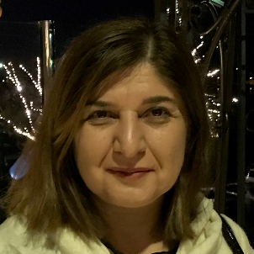 | My approach to teaching, educational management and leadership is based on the principles of equality, empathy, empowerment, and best practices. Thus, I continually work to ensure high standards of learning and teaching as well as efficient and collaborative management of the ACU English Language Centre on North Sydney campus. In this work, I do my best to apply the knowledge gained from several management and leadership programs such as Emerging Leaders and Managers Program and in-house workshops developed by the Australian Institute of Company Directors.  I have been involved in the Australian ESL community for eighteen years. In 2018, I was a part of EA Conference Organising Committee, and I am an active member of EA AMSIG committee. My involvement in the EFL community started much earlier back in Europe when I was the owner and the manager of a private language school for 10 years.  My deep appreciation of other cultures and languages has been enriched during my extensive travel as well as my own learning of several languages. In 2018, I was the recipient of the Vice-Chancellor’s Staff Excellence Award for a community engagement program that supported refugees and migrants. Last year, I chaired the Professional Development Working Party and developed Professional Development Framework for our Education Pathways Directorate.  I hold a BA in English and English Literature, CELTA and TEFL Certificates, and an MA in TESOL. At this stage of my professional life, I would like to contribute to the wider ELT community and NEAS members. I believe that my sound knowledge and understanding of cultural and language differences, ability to identify the needs of individual students and groups, teachers, and colleagues, and all NEAS members, as well as high-level communication and organization skills would be useful in the role of a Board Director.

Prof. Thomas Roche  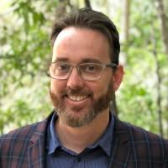 | Thomas is the Dean of SCU College (Direct Entry and General English ELICOS, Enabling and Diploma courses) and Pro-Vice Chancellor (Academic Quality) at Southern Cross University. He is a specialist in the design, delivery and management of English language and higher education pathways, empowering students from culturally and linguistically diverse backgrounds gain access to and succeed in university study.  His more than 20 years of post-secondary education professional experience, in Australia and abroad, demonstrates a long-standing commitment to ensuring that English language courses deliver an inspired experience for students. While much of his professional experience has been working with University students studying academic English, he has also worked designing and delivering English courses for recently settled migrants from CALD backgrounds, work-and-holiday travellers, as well as primary school pupils’ Study Tours. His research interests are in applied linguistics and he has published on English for Academic Purposes, vocabulary knowledge, language testing, pronunciation teaching and digital literacy.  In 2018-2019 he co-led the University English Centres Australia (UECA) national initiative: the External Referencing of the ELICOS Standards and International Education [ERESIE] Project. 20 Australian universities participated in the project to benchmark ELICOS program outcomes. In 2020 he was the UECA Assessment Symposium Chair and host. He is a member of the Australian Government’s TEQSA Expert Register for ELICOS and international education. He is well known for his collegiate approach and silly sense of humour. He would like to represent English Centres on the NEAS Board, advocating for quality outcomes for their students, staff and communities.

